

**NoSQL and DBaas(Project)**

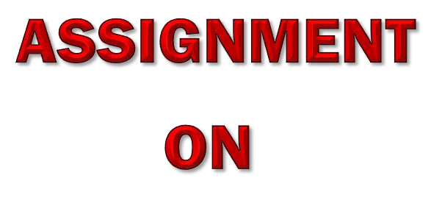

|  |  |
| --- | --- |
| **Submitted By** | **Submitted To** |
| **Mangesh Yadav** | **Mr.Ankit Verma** |
| **Roll No. 1240258248** |  |
|  |  |